

**A Student’s Guide to**

**REVISION**



**How the brain works**

Revising is all about MEMORY. The memory is like a muscle. If you don’t exercise it, it will grow weaker, but if you do exercise it, it will get stronger and stronger.

TAKE LOTS OF BREAKS

Most people can only concentrate, understand and remember **for between 20 and 45 minutes at a time**.

DO NOT REVISE FOR LONGER WITHOUT A BREAK.

If you do, most of what you do, you will not remember.

Once you have finished learning something, your brain actually increases its power and carries on remembering. It will be sorting out what it has been learning, creating a more complete picture of everything it has just learnt. Only then does the rapid decline in memory begin and as much as 80% of what you learn in a day can be forgotten almost immediately.

BUT WHAT CAN I DO TO STOP THIS?

To maximize your learning, you need to catch the top of the wave of your memory. To do this, you need to look back at what you have been revising at the correct time, when the memory is stamped in far more strongly, and stays at the crest of the wave for a much longer time. Look at the diagram below:

[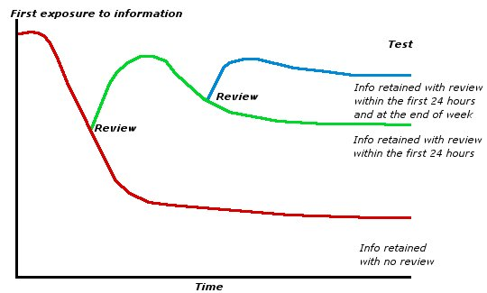](http://www.google.co.uk/url?sa=i&rct=j&q=&esrc=s&frm=1&source=images&cd=&cad=rja&uact=8&docid=UbZO_gi2eNFuLM&tbnid=GeqStdDRoan7JM:&ved=0CAUQjRw&url=http://www.wwu.edu/tutoring/note_taking.shtml&ei=BfsyU-PwMci90QW0n4DADQ&psig=AFQjCNHE_lKtNS7wpgAaLpKfWA5Hyoa1HQ&ust=1395936383253443)

YOU NEED TO REVIEW WHAT YOU HAVE LEARNT:

* After 10 minutes
* At the end of the day
* At the end of the week
* At the end of the month

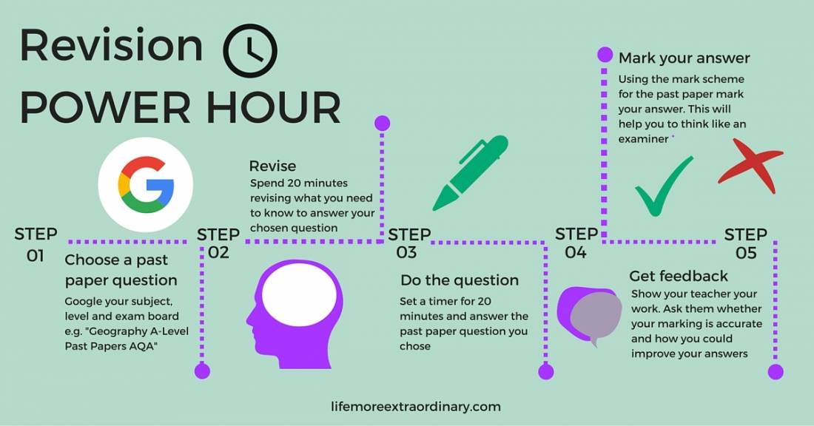

**What type of learner are you?**

Tick the statements which best describe you, your actions and the things that you say.

1. “I see what you mean”
2. “That sounds right”
3. “That feels right”
4. “I get the picture”
5. “I hear what you are saying”
6. “I found it easy to handle”
7. “That looks about right”
8. “That rings a bell”
9. “That touched a nerve”
10. When relaxing, I like to watch a film or video.
11. When relaxing, I like to listen to music
12. When relaxing, I like to go to the gym
13. I like to read a book to relax
14. When relaxing, I like to listen to the radio
15. When relaxing, I play sport
16. I prefer to talk to people face to face
17. I prefer to talk to people on the telephone
18. I prefer to talk to people whilst I’m doing something else
19. I get impatient when I listen to others
20. I like listening to others
21. I wave my hands about a lot when I’m talking
22. I forget people’s names, but I remember their faces
23. I don’t forget people’s names
24. I shake hands when I meet people
25. If I’m lost or need directions, I prefer a map
26. If I’m lost or need directions, I prefer to be told
27. If I’m lost or need directions, I prefer to be shown the way
28. When I’m bored, I doodle
29. When I’m bored I tend to chat
30. When I’m bored, I fidget
31. When I’m angry, I seethe and say nothing
32. When I’m angry, I have an outburst and sometimes shout
33. When I’m angry, I clench my teeth or storm off
34. When I want to reward someone, I write them a note or send them a card
35. When I want to reward someone, I tell them
36. When I want to reward someone, I pat them on the back or hug them
37. I’m well organised
38. I don’t like reading books or instruction manuals
39. I can’t sit still for very long

**What type of learner are you?**

Now check your learning style:

[](http://www.google.co.uk/url?sa=i&rct=j&q=&esrc=s&frm=1&source=images&cd=&cad=rja&uact=8&docid=FGrxZN41rTmXAM&tbnid=w7IrajaVpLl79M:&ved=0CAUQjRw&url=http://lmyefski.wordpress.com/2011/04/01/visualize-it/&ei=z_gyU8vBHOmS1AXY2oCADA&bvm=bv.63738703,d.ZGU&psig=AFQjCNF4wHb1O9o6v9cveZvcmvNRisiq4g&ust=1395935742447495)

1. Visual learner

I ticked the following questions:

1, 4, 7, 10, 13, 16, 19, 22, 25, 28, 31, 34, 37

C:\Users\karen.stirk\AppData\Local\Microsoft\Windows\Temporary Internet Files\Content.IE5\DUPMQ7HK\MC900064950[1].wmf

1. Auditory learner

I ticked the following questions:

2, 5, 8, 11, 14, 17, 20, 23, 26, 29, 32, 35, 38

[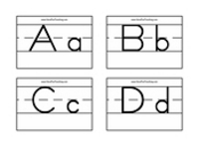](http://www.google.co.uk/url?sa=i&rct=j&q=&esrc=s&frm=1&source=images&cd=&cad=rja&uact=8&docid=QUA1aa9NR6ydyM&tbnid=RpwG1CvTpATOnM:&ved=0CAUQjRw&url=http://www.havefunteaching.com/flash-cards/alphabet-flash-cards&ei=ouYzU8mmBYTx0gXA74GwCQ&bvm=bv.63808443,d.ZG4&psig=AFQjCNEq75Bqf8TI06OhrIreWGYd5yRwcg&ust=1395996602146852)

1. Kinaesthetic learner

I ticked the following questions:

3, 6, 9, 12, 15, 18, 21, 24, 27, 30, 33, 36, 39

**Good techniques for you to use**

[](http://www.google.co.uk/url?sa=i&rct=j&q=&esrc=s&frm=1&source=images&cd=&cad=rja&uact=8&docid=QPFUggAuNOMhvM&tbnid=lfBxf8VIbudOIM:&ved=0CAUQjRw&url=http://www.freepik.com/free-vector/colored-pencils-in-pencil-case_677104.htm&ei=P_AzU6W5K6O40QXjm4C4Dw&bvm=bv.63808443,d.ZG4&psig=AFQjCNED-E8ICL-U85gNwszT9Q-sdhW0xQ&ust=1395999102520774)[](http://www.google.co.uk/url?sa=i&rct=j&q=&esrc=s&frm=1&source=images&cd=&cad=rja&uact=8&docid=VJlVxAb07pnoMM&tbnid=3L7s97CEoJ4hUM:&ved=0CAUQjRw&url=http://sequinofkindness.org/&ei=UO8zU-eiMu3K0AXRs4CYDw&bvm=bv.63808443,d.ZG4&psig=AFQjCNEVBnCoQaz4PIYgBJKRlh4Cv6WBFw&ust=1395998906978854)[](http://www.google.co.uk/url?sa=i&rct=j&q=&esrc=s&frm=1&source=images&cd=&cad=rja&uact=8&docid=FGrxZN41rTmXAM&tbnid=w7IrajaVpLl79M:&ved=0CAUQjRw&url=http://lmyefski.wordpress.com/2011/04/01/visualize-it/&ei=z_gyU8vBHOmS1AXY2oCADA&bvm=bv.63738703,d.ZGU&psig=AFQjCNF4wHb1O9o6v9cveZvcmvNRisiq4g&ust=1395935742447495)

Auditory Learners

**Hearing a presentation**

**Reading aloud to yourself**

**Making a take with key points to listen to**

**Verbally summarizing**

**Explaining your subject to someone else**

**Talking to yourself**

**Make a podcast**

**Using Mnemonics**

**Use computer software**

KINAESTHETIC LEARNERS

**Using highlighters to select key words, main ideas before making notes. Use a black out pen to block out unnecessary words.**

**Make flash cards**

**Make sort cards and put into order**

**Make models**

**Record information as you hear it – i.e. on a mind map**

VISUAL LEARNERS

**Writing down key facts**

**Using mind maps**

**Creating pictures and diagrams**

**Using timelines**

**Using pictures, diagrams and charts**

**Watching videos, films or TV programmes**

**Getting started**

Before you start revising, it is worth making sure you have everything you need at your fingertips. This will stop you wasting valuable time trying to find things.

[](http://www.google.co.uk/url?sa=i&rct=j&q=&esrc=s&frm=1&source=images&cd=&cad=rja&uact=8&docid=hc-qIfRvC0vRyM&tbnid=z3FuNGVRMLD1pM:&ved=0CAUQjRw&url=http://www.publicdomainpictures.net/view-image.php?image%3D47463%26picture%3Dhighlighter-marker-pen-pink&ei=NOgzU42bC-iG0AX04YDwAw&bvm=bv.63808443,d.ZG4&psig=AFQjCNGJlJbZaYqy5Wwx4WlWNKICzEoAEA&ust=1395997063640128)

**EQUIPMENT**

* **Highlighters**
* **Coloured pens**
* **Post-it notes for formula/key words**
* **Different coloured paper for different subjects (you will need lots of this)**
* **Cd player/computer for revision CD’s**
* **Smart phone for making podcasts**

**C:\Users\karen.stirk\AppData\Local\Microsoft\Windows\Temporary Internet Files\Content.IE5\RL2YVOH5\MC900446326[1].wmf**

**WHERE TO REVISE**

* **Not in front of the TV**
* **At a table, preferably in a quiet place**
* **It’s worth trying to sort the bedroom out. Get rid of the clutter, so you have work space.**
* **Keep all materials for each subject in one place to save time.**

**WHAT DO YOU NEED TO REVISE?**

* **Revision timetable**
* **An up to date set of class notes**
* **Any revision materials given out by departments**
* **Revision lists**
* **Lists of exactly what is in each exam**
* **Any study guides which have been bought (check with your teacher that it is the right one)**

**REVISION TIMETABLES**

Topics need to be revised more than once based on what we know about the brain.

Think about the following:

* [](http://www.clker.com/clipart-6230.html)Be realistic – remember sessions should only be for 30 – 40 minutes with 10 minute breaks
* Start **NOW**
* 2 sessions on a week night
* 3-4 sessions a day at the weekend
* During holidays revision should be far more intensive
* Build in treats – time with friends, evenings out etc. Social time is vital in the overall scheme, as long as there is a balance between work and play
* Try and get a variety of subjects across each day.
* Build in slots to review the learning of the day
* When you write next week’s timetable, remember to include review slots for the work covered last week
* Discuss with someone at home how you are going about your revision

Breaking it down:

If you’re thinking, “I’m doing Maths for 40 minutes and then half an hour of French”, think again! It means you haven’t broken the subject down into key areas to tackle your work in an organised manner; e.g. “I’m doing algebra and irregular verbs”. You should have a list of topics, and if not then you must ask your teachers for one.

You need to use those key headings to:

* Identify those topics you feel weak in – the danger is you push these to the back of your mind.
* Use each heading to break the topic down further. On the next page is one way of doing this.

**TIP: At first, the big picture may look and feel totally overwhelming. You need to prioritise your workload. You need to be aware of the fact that revision takes time and for a few months, the social life has to give a bit. Why don’t you arrange with friends to have “time off” sessions together?**

C:\Users\karen.stirk\AppData\Local\Microsoft\Windows\Temporary Internet Files\Content.IE5\RL2YVOH5\MC900440424[1].wmf

**planning your revision**

THINK LEVELS!

LEVEL ONE IS THE SUBJECT

LEVEL TWO IS THE TOPICS WITHIN THAT SUBJECT

LEVEL THREE IS THE INDIVIDUAL TOPIC DIVIDED INTO STUDY UNITS

SUBJECT

C:\Users\karen.stirk\AppData\Local\Microsoft\Windows\Temporary Internet Files\Content.IE5\LLUNZEZ2\MC900437990[1].wmf

**STUDY**

**UNITS**

**1**

**2**

**3**

**4**

**5**

**STUDY**

**UNITS**

**1**

**2**

**3**

**4**

**5**

**STUDY**

**UNITS**

**1**

**2**

**3**

**4**

**5**

**STUDY**

**UNITS**

**1**

**2**

**3**

**4**

**5**

**STUDY**

**UNITS**

**1**

**2**

**3**

**4**

**5**

TOPIC

TOPIC

TOPIC

TOPIC

TOPIC

Timetable:

|  |  |  |  |  |  |  |  |
| --- | --- | --- | --- | --- | --- | --- | --- |
|  | Mon | Tues | Wed | Thurs | Fri | Sat | Sun |
| 8 am |  |  |  |  |  |  |  |
| 9 am |  |  |  |  |  |  |  |
| 10 am |  |  |  |  |  |  |  |
| 11 am |  |  |  |  |  |  |  |
| 12 noon |  |  |  |  |  |  |  |
| 1 pm |  |  |  |  |  |  |  |
| 2 pm |  |  |  |  |  |  |  |
| 3 pm |  |  |  |  |  |  |  |
| 4 pm |  |  |  |  |  |  |  |
| 5 pm |  |  |  |  |  |  |  |
| 6 pm |  |  |  |  |  |  |  |
| 7 pm |  |  |  |  |  |  |  |
| 8 pm |  |  |  |  |  |  |  |
| 9 pm |  |  |  |  |  |  |  |
| 10 pm |  |  |  |  |  |  |  |

**GENERAL REVISION STRATEGIES**

The following 21 ideas can be used for turning class notes into revision notes across all subject areas.

* Deliberate aspects of a topic using a spider diagram
* Make a chart to fit the information
* Put key words onto Post-It Notes, stick then around the house to learn them
* [](http://www.google.co.uk/url?sa=i&rct=j&q=&esrc=s&frm=1&source=images&cd=&cad=rja&uact=8&docid=cMrRUJ3qshuPaM&tbnid=GEdoTt4mqacGiM:&ved=0CAUQjRw&url=http://www.aperfectworld.org/special_occasions.html&ei=lvIzU4GdDK3s0gXXrYHgDw&bvm=bv.63808443,d.ZG4&psig=AFQjCNF-8npNWD9o-plvWurFsdM37--qkA&ust=1395999739416739)Make up tests to try later
* Put notes onto revision cards
* Make your own flash cards – questions one side/answers on the back
* Create a Mind Map (see later section)
* Use different colours to represent different things
* [](http://www.google.co.uk/url?sa=i&rct=j&q=&esrc=s&frm=1&source=images&cd=&cad=rja&uact=8&docid=cMrRUJ3qshuPaM&tbnid=GEdoTt4mqacGiM:&ved=0CAUQjRw&url=http://www.aperfectworld.org/special_occasions.html&ei=lvIzU4GdDK3s0gXXrYHgDw&bvm=bv.63808443,d.ZG4&psig=AFQjCNF-8npNWD9o-plvWurFsdM37--qkA&ust=1395999739416739)Use Mnemonics for difficult spellings/sequences (e.g Richard of York Gave Battle In Vain – colours of rainbow)
* Make a flow chart
* Make a timeline
* Use pictures to represent key ideas
* List two sides of an argument
* Identify similarities/differences
* Plan an exam answer and write the first paragraph
* Create a dictionary for each subject
* [](http://www.google.co.uk/url?sa=i&rct=j&q=&esrc=s&frm=1&source=images&cd=&cad=rja&uact=8&docid=cMrRUJ3qshuPaM&tbnid=GEdoTt4mqacGiM:&ved=0CAUQjRw&url=http://www.aperfectworld.org/special_occasions.html&ei=lvIzU4GdDK3s0gXXrYHgDw&bvm=bv.63808443,d.ZG4&psig=AFQjCNF-8npNWD9o-plvWurFsdM37--qkA&ust=1395999739416739)Turn headings into questions
* Fill the bedroom walls with posters for key ideas
* Make up cartoons
* Label pictures
* Record key quotes/key terminology