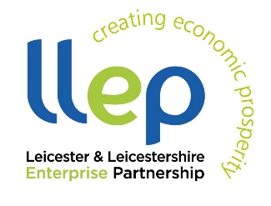
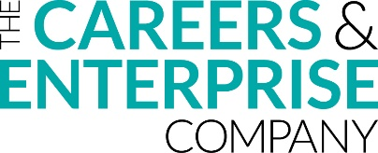

10 ways to achieve careers education at home

- Explore different job roles and the job market

Videos featuring real people talking about their careers

Information about different job roles

Information about over 350 job roles within the NHS

Lesson plans and articles

Quiz to find jobs that are suited to you

Leicester and Leicestershire labour market Information

Labour market lesson plan and resources

More labour market information

View careers by industry

- Find out about different courses and pathways

Information about apprenticeships

Virtual Tours and information on Leicester Universities

University exploration and course search

Guides on how subjects link to different careers

Compare universities

Information about uni alternatives

Advice on how to work in certain sectors

Leading university information

Search for courses by location

- Have a debate

Debate career myths and stereotypes with someone else (online or face-to-face):

“Bricklaying is a man’s job”
“Caring jobs (nurse, teacher, vet etc.) are for females”
“Only rich people go to university”
“Apprenticeships aren’t for academics”
“You need all A’s in your A Levels to go to University”
“Creative Industries don’t make any money”

Follow this up by researching online and writing down your thoughts.

- Watch educational videos and documentaries

BBC Bitesize

Stacey Dooley’s BBC Series

Follow this up by writing about what you learnt.

- Play an educational game

Microsoft Minecraft

- Discover and build upon your skills and strengths

Life skills lesson plans and resources

Lesson plan and worksheet (Use CVDTWINKLHELPS code for free access)

A range of skills-based activities and information

Take this personality quiz

Skills employers want

- Print and complete worksheets/workbooks

PSHE workbooks

Citizenship workbooks

Skills and activities workbook

Free careers guides for all subject areas

Home Learning Hub for parents, students and teachers

STEM Learning Family Activities

- Take a free online course or lesson

30 Minute Apprenticeship in Business

30 Minute Apprenticeship in Construction

30 Minute Apprenticeship in Marketing

Strengths and Skills (Lesson)

Staying Positive (Lesson)

Finding your Cyber Security Career Path (Free online course)

Career Skills for Investment Banking and Finance (Free online course)

Creativity and Entrepreneurship (Free online course)

Resilience, the art of coping with disasters (Free online course)

Prepare for career success at Uni (Free online course)

Building your career in tomorrow’s workplace (Free online course)

How to start your career in games development (Free online course)

How to succeed in interviews (Free online course)

- Create a CV and/or write a personal statement

Free app for CV creation

CV Builder
CV writing guidance

Personal statement guide

- Browse Careers websites

Careerpilot

Start Profile

Bridge U

Springpod

National Careers Service

BBC Bitesize

My Career Springboard

Careers Box

Success at School

Gov: Apprenticeships

Gov: Careers helpline

All About Apprenticeships

All About School Leavers

Career Connect

Shaw Trust (SEND)

Careers Advice for Parents

Here are also some general free online learning sites!

MOOC (Online courses for anyone)

Minecraft (Educational games and activities)

TES (Resources & lesson plans)

Twinkl (Online lessons & activities - Use CVDTWINKLHELPS code for free access):

BBC Bitesize (Online lessons and revision)

Seneca (Online interactive lessons)

Future Learn (Free online courses):

TED (Video lessons)

