Transition booklet (David and Anjum COMPLETED)

Here at Gateway we can appreciate and understand you might be nervous about starting at College. This is totally understandable. However, we feel it is also an exciting time to meet new friends and hopefully see some old ones. It is also a great opportunity to learn new things which can help you grow as a person and learning can be fun too.
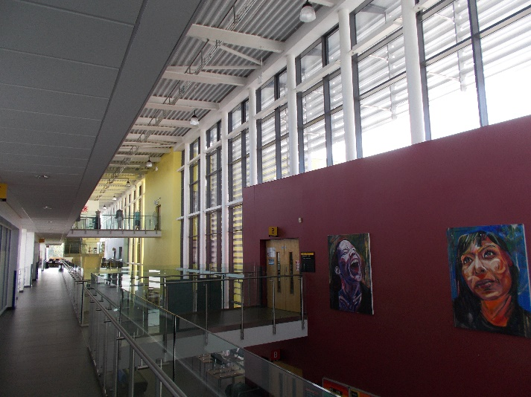
At Gateway we have many staff members that are here to help support you with your learning. Alongside the excellent teachers we have a large team of brilliant support staff with lots of experience helping students, these are called Education Care Support Workers (ECSW) We understand you might be nervous, but we will try our best to help you and make you feel welcome.

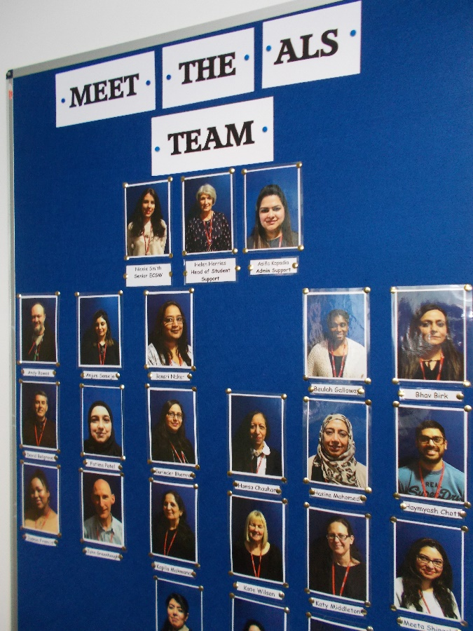
Transport:
Many of our students make their own way to College, they might walk or cycle. Some students are lucky enough to be dropped off at College. However, some students take transport, this means coming by taxi, also being taken home by taxi. You can get dropped off and collected from very near to your classrooms which will make life easier for you. The college can help provide lots of information about transport, this is not something to worry about.
Care:
Some students might require personal care whilst at College. This might also include help with lunches or taking any medications. The staff totally understand and have helped lots of students with this. However, we understand and respect your dignity and we are here to help, but only if you want and need us too. The support staff can also help you if you want to visit the college canteen, a very busy place. We can help carry your food or help you decide what to have for your lunch, its all about you and we will help where we can.
In-class support:
Your teacher will lead in your lessons, also you might have support staff in the lesson too. The staff will be there to help you with your work, answer questions and help you be your best whilst learning. This is an enjoyable part of what the staff do at Gateway. We enjoy seeing students do well, we want you to work hard in your lessons and we will support you to do your very best.
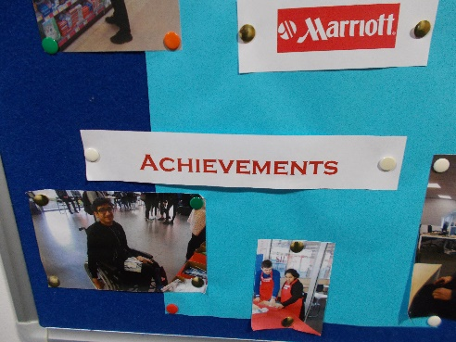
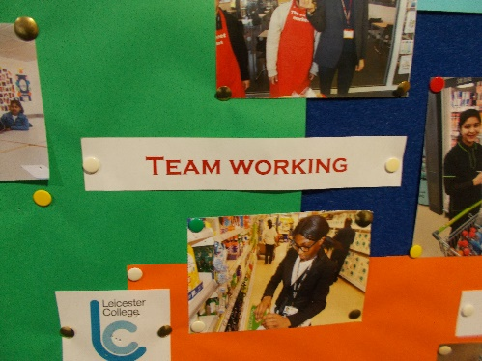

Workshops:
Between lessons you might have workshops on your timetable. These are run by ECSW staff and are there as extra time for you to complete work. We find some students might need extra time or might have questions, this is a great place and an opportunity to answers those questions and get work completed. Other students might be in the same room, this is a great chance to share ideas or make new friendships. It is available for all students and if you do feel like you need it do not feel worried about asking us, we want to make you journey at Gateway College the best experience for you. We will support you every step of the way.
