Welcome to Gateway and Learning for Life and Work

Multiskills booklet Transition support …….

Name:_______________________
Welcome to Gateway College

You will be starting at Gateway College in August to start a new course here.
Teachers and Tutors you will meet in LLW

Head of Department/School LLW
Annie Atiken CL LLW
Vikram Goraniya Teacher LLW

There are lots of support staff that can help you and care for you at college.

Places in Gateway College I will use
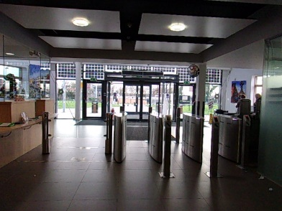
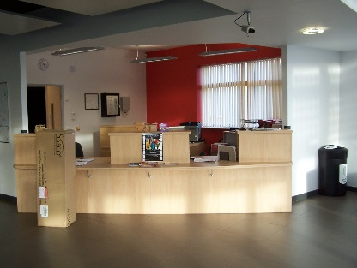

This is our college reception.
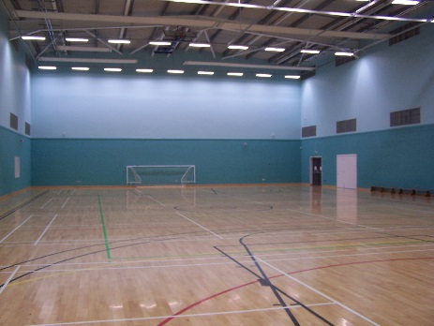

This is our college sports hall.
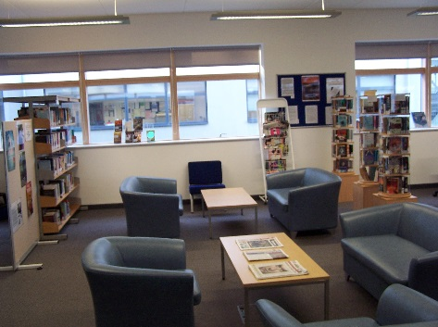
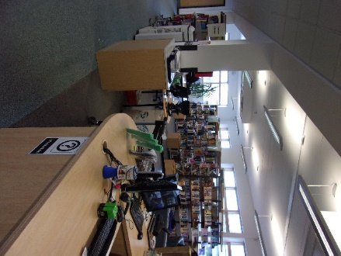

This is our college library.

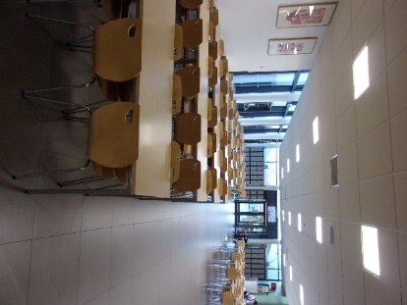
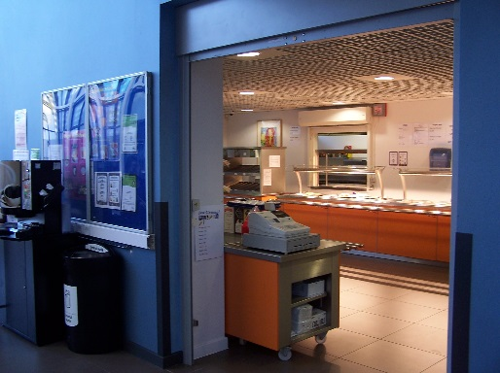

This is our college canteen.
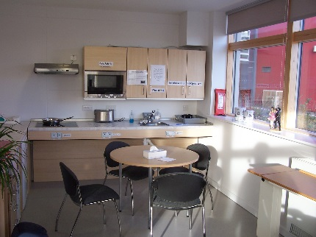
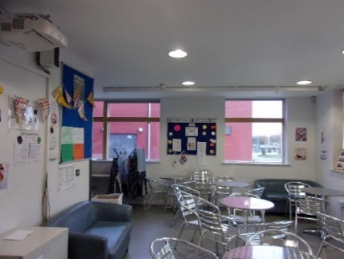

This is LLW C block – Pop up café/Kitchen

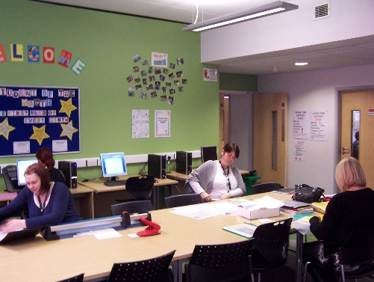

This is our LLW C block resource area

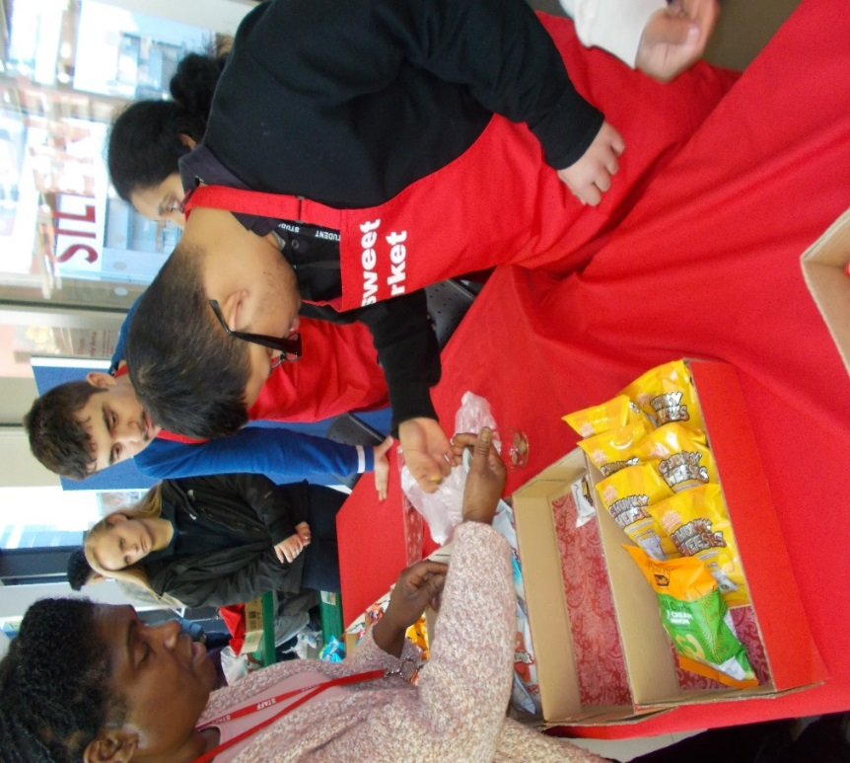
This is our college sweet market

How will I know when I am starting college?
- You will be asked to come into college with your parent to talk about your course and learning support you need at college.
What days will I be at College?
- I will be attending college on Monday, Tuesday and Thursday only. I will have Tuesday and Friday day off at home.
This year I will carry on making progress with the following Preparing for Adulthood themes:

Health and Fitness
Playing sports
Exercise
Going to the chemist/medication
First Aid
Emergency calls
Personal hygiene – using showers
Employment

Working in the college shop/café in the street
Creating gifts/ sweet boxes
Working with customers
Independent Living/Out and About
Shopping
Cooking for myself
Breakfast club
Health and safety
Ironing and laundry
Using equipment in the kitchen and home
Spending time in the summer house
IT

Word processing
Using mobile phones/cameras
Emails IPads Technology in the community

Numeracy and Literacy skills will be part of every lesson!
Where are my lessons?
- You have your lessons in C002, Kitchen and the Gym.
- When you are working at break you will be in the street area or in the shop working.

What do I need to bring to college?
Bag 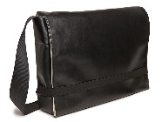 | Pen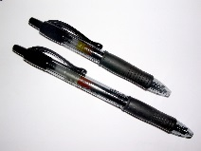 | Money for lunch/packed lunch and £1.00 if you want to buy from the pic n mix at break time.
Every day you will need to take home your communication book and home learning book.

Being safe when Out and About: What do we need to remember?
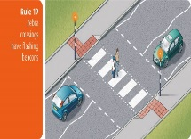

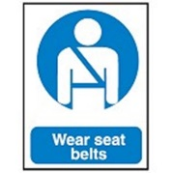

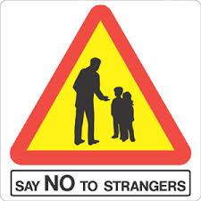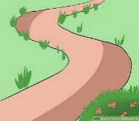

Questions you may still have ………?????

Write your questions here:
________________________________________________________________________________________________________________________________________________________________________________________________________________________________________________________________________________________________________________________________________________________________________________________________________________
Send your question to us:
Send your question to us now at kreeve@gateway.ac.uk or hbishop@gateway.ac.uk.

Follow the Department on …………………………………
Find Gateway College@Gateway_LLW.
Explore all the fun activities we do with our students on different courses.

Notes:
________________________________________________________________________________________________________________________________________________________________________________________________________________________________________________________________________________________________________________________________________________________________________________________________________________________________________________________________________________________________________________________________________________________________________________________________________________________________________________________________________________________________________________________________________________________________________________________________________________________________________________________________________________________________________________________________________________________________________________________________________________________________________________________________________________________________________________________________________________________________________________________________________________________________________________

