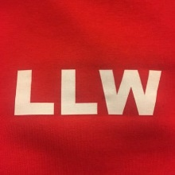

Welcome to Gateway and Learning for Life and Work

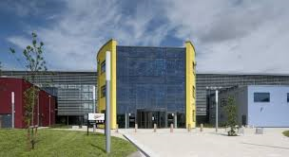

Supporting your transition to us…………

Name:_______________________

Welcome to Gateway College

Welcome to Entry/Level 1 courses at Gateway College. We are looking forward to you joining us in September.

We would usually hold a welcome day at college but due to the current lockdown circumstances this is unlikely to happen. We have put this information together to support you getting to know the college a little bit more before you begin in September 2020.

Contents of your pack
- Getting to know your teachers (Have you met any of these yet?)

- Key places/pictures of areas in Gateway College (Read this)

- Some information about starting college (Read this)

- Key words we use at Gateway College (Read this)

- Some Transition fun activities to complete before you start with us

- Worries you may have and questions you may have …….??

Teachers and Tutors you will meet in LLW

Head of Department/School LLW
Hannah Bishop CL LLW
Annie Atiken CL LLW
Laura Brewin CL LLW
Taz Shamsi Teacher LLW
Nilpa Jethwa Teacher LLW
Mandip Kaur Teacher LLW
Vikram Goraniya Teacher LLW
Sophie Hayman Teacher LLW

We also have a brilliant team of ECSW support staff to help you in the classroom and around college if you need it. These staff are led by Helen Herries (Head of Learning Support), and Nicole Smith (Senior ECSW).
Key places and facts about Gateway College
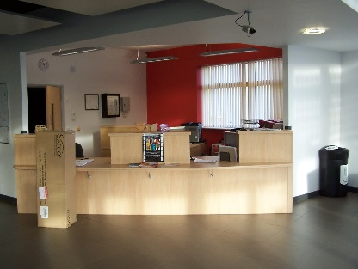
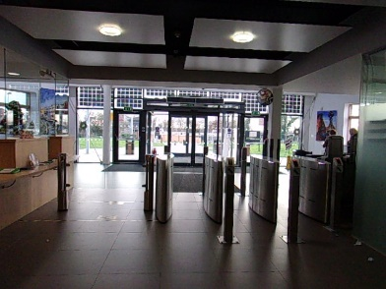

This is our college reception.
- When you begin college you will get an ID card with your photo and student number on it.
- YOU MUST WEAR YOUR ID CARD ON YOUR LANYARD AT ALL TIMES, SO THAT WE CAN IDENTIFY YOU.
- You will need it to swipe through these barriers to get in to the building. (C block entrance is also quieter and if you use special transport you will be dropped here)
- You also use your ID card to print work out from the photocopier, borrow things from the library and use the lifts.
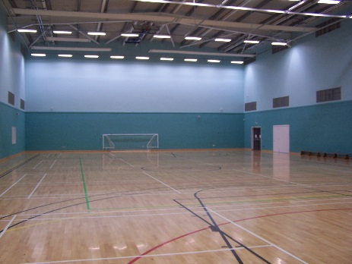

This is our college sports hall.
- You will have some of your lessons in here to play games and activities.

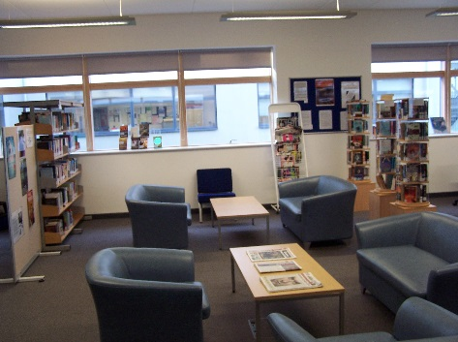
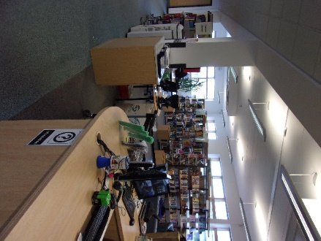

This is our college library.
- You can use your ID card to borrow books, laptops, or just come and use the quiet space to relax and read.
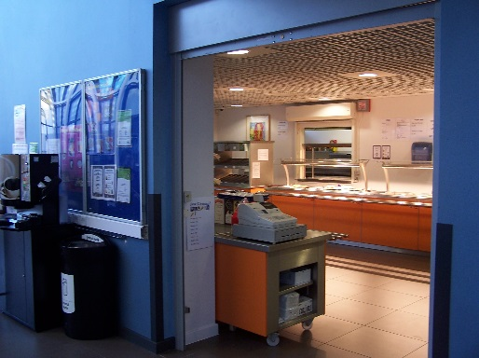
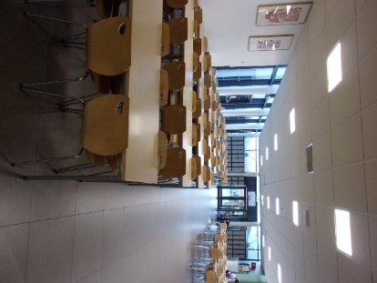

This is our college canteen.
- You can buy a hot lunch here if you want to.
- You will need about £3.50 for something to eat and a drink. The LLW ECSW support team can help you in the canteen.
- You can eat your hot meal here or bring food from home if you prefer this.
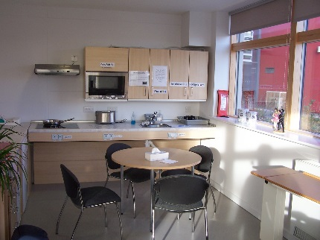
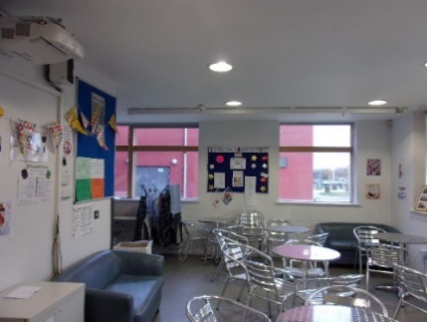

This is LLW C block – Pop up café/Kitchen
- If you find the canteen a bit too busy and noisy you can come and eat in our LLW café.
- The ECSW support team can help you here.
- There is also a kettle and microwave if you want to heat up food from home or make a hot drink (you will need to bring your own labelled milk, tea or coffee and we can store it in our kitchen or fridge for you).
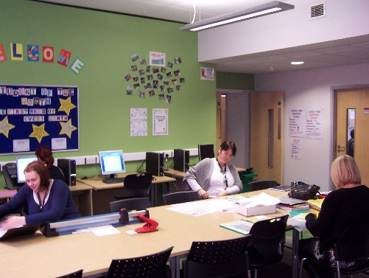

This is our LLW C block resource area
- Most of your lessons will be in C block classrooms as this is where we are based.

- You can use the computers here for your work and the ECSW support team will be around to help you if you need them.

How will I know when I am starting college?
You will be invited to an enrolment appointment at the start of September. Here you will meet your teachers, get your timetable and receive your ID card. You will receive a letter about this in August. If you have any questions about this please contact the college and someone will try and answer them!

You will also get a course induction book in September, which has lots of information in it about the canteen, the library, ID cards, and trips & visits. You will not be left on your own!

The College day
- The college day is from 9am until 4pm. You will not be in college all day every day.
- Your timetable will tell you when your lessons are.
- Break time is at 10.30 -10.45
- Lunch time 12.15 – 1.00
- On Friday afternoons there are no lessons but the LLW department runs a workshop then to help any students who need a bit of extra time to complete some work.

Gateway College key words

Here are some other key words you may hear around college and what they mean.
- Student Services – there are staff here to help you with any questions you may have about your time at college (like bus passes, or bursaries).

- Finance Department – here you pay in money and deposits for things.

- The Theatre – we have a large theatre where you will attend assemblies as part of you tutorial programme.

- The Street – this is our main walkway inside the building. We call it “The Street” because the original Gateway College in Leicester was built on Gateway Street!

- Tutor – this is the person who looks after you while you are at college. Your tutor will meet with you and discuss your progress and any problems you might have.

- Tutorial - this lesson is with your whole group. You will find out what is happening in college, your attendance and receive weekly notices

- Reprographics – this is the area that all our photocopying and stores all our college paper.
Some activities for you to complete before you start college – based on the information in this book!
Unscramble the letters to make the names of different things and places you will find at Gateway College.

orecnetpi  _ _ _ _ _ _ _ _ _ | You report here if you have to leave college. You ring this office if you can’t come to college.
efiancn  _ _ _ _ _ _ _ | You pay your deposit here. You can get information about your bursary here.
ntsdetu rsivcese  _ _ _ _ _ _ _ _ _ _ _ _ _ _ _ | The nice people here can answer your questions about Gateway and help you if you have a problem.
het ectanen  _ _ _ _ _ _ _ _ _ _ | You can buy and eat a cheap, delicious meal here!
eth arlbyri  _ _ _ _ _ _ _ _ _ _ | You can borrow books here, work quietly and use a computer.
het arc rpka  _ _ _ _ _ _ _ _ _ _ | Gateway staff and visitors park their cars here!
nvengdi hincmae  _ _ _ _ _ _ _ _ _ _ _ _ _ _ | You can buy drinks and snacks from this.
teh hreetat  _ _ _ _ _ _ _ _ _ | You can watch and take part in dance and drama activities here.
TI rmoo  _ _ _ _ _ _ | You will have lessons on the computer in here.
het rsetet  _ _ _ _ _ _ _ _ _ | You can relax with your friends here. It is the main corridor in the college.

Gateway Word search

How many words can you find?

S | J | M | V | P | C | N | M | J | K | L | P | S
P | E | A | R | E | O | W | E | T | E | N | A | T
O | A | T | W | N | L | V | N | X | R | M | P | U
R | N | H | S | F | L | B | T | Y | R | O | E | D
T | Q | S | T | A | E | E | O | R | Y | E | R | E
S | U | I | R | T | G | M | R | C | C | N | U | N
T | Q | A | X | T | E | S | C | O | V | I | F | T
T | U | T | O | R | I | A | L | B | P | R | I | S
S | T | R | E | E | T | Z | C | B | V | E | L | U
D | C | O | O | K | I | N | G | S | A | H | E | M
R | E | T | A | I | L | X | S | B | N | T | U | E
A | T | E | A | C | H | E | R | U | T | A | K | L

Record your answers here:

Getting to know you: Make a big life board …………..
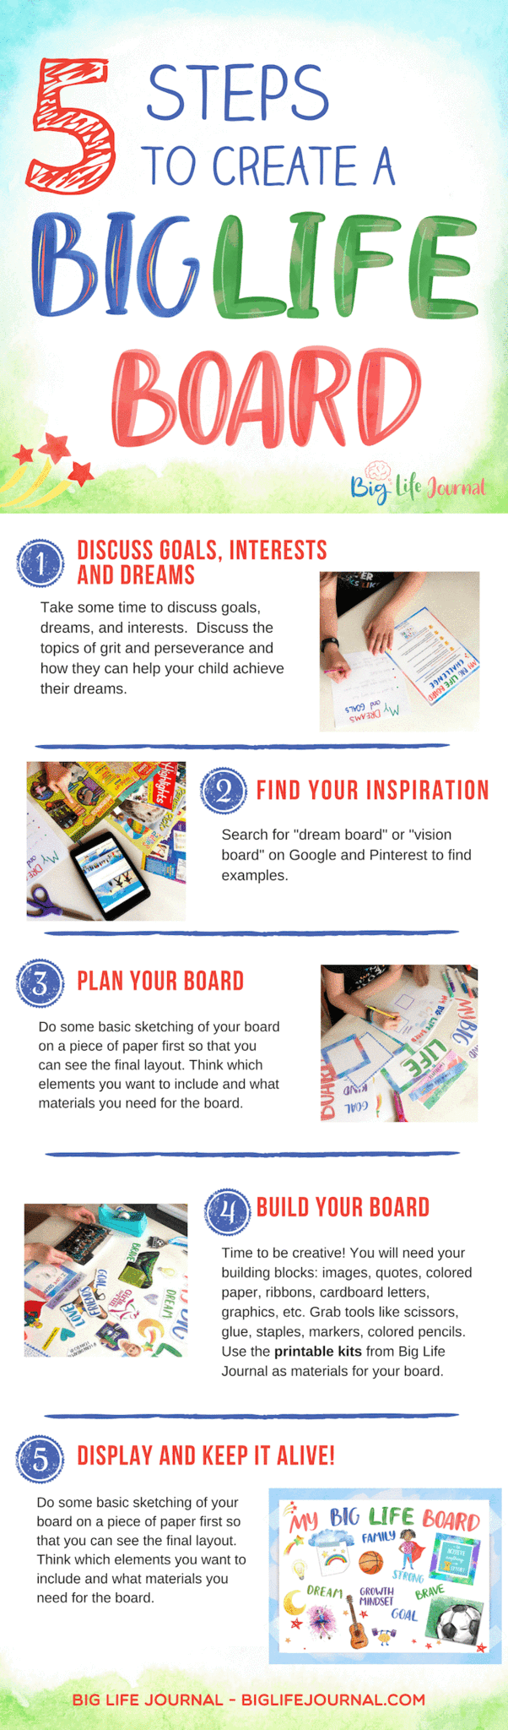
Worries you may have ………….

Question 1
I might get lost and don’t know where to go?

We will help you find your way round college.

Question 2
Will I get homework? How does this work?

Your individual teachers will set work for you to complete.

Question 3
Am I going to make friends? Am I going to be bullied?

You will make friends with all the students in your class. You will spend lots of time with them. Speak to your Tutor, Hannah or Kerry if you have any issues.

Questions you may still have ………?????

Write your questions here:
________________________________________________________________________________________________________________________________________________________________________________________________________________________________________________________________________________________________________________________________________________________________________________________________________________
Send your question to us:
Send your question to us now at kreeve@gateway.ac.uk or hbishop@gateway.ac.uk.

Follow the Department on …………………………………
Find Gateway College@Gateway_LLW.
Explore all the fun activities we do with our students on different courses.

Notes:
________________________________________________________________________________________________________________________________________________________________________________________________________________________________________________________________________________________________________________________________________________________________________________________________________________________________________________________________________________________________________________________________________________________________________________________________________________________________________________________________________________________________________________________________________________________________________________________________________________________________________________________________________________________________________________________________________________________________________________________________________________________________________________________________________________________________________________________________________________________________________________________________________________________________________________

